Analyzing trends of Land Surface Temperature with NDVI and NDBI using Landsat 8 Thermal Infrared Sensor Data in Google Earth Engine: A Case Study in Bangkok Metropolitan Region Area, Thailand.
Bussakon Satta*, Priyanuch Sopha, Adisak Thongya, Suvalak Nakya, and Worawee Wimon, Thanwarat Anan
Geo-informatics and Space Technology Development Agency
Bangkok, Thailand
Email: bussakon@gistda.or.th, priyanuch.sopha@gmail.com, adisak.th0248@gmail.com, suwalak@gistda.or.th,
worawee.wim@gistda.or.th and twarat@gistda.or.th

KEY WORDS: Land Surface Temperature (LST), normalized difference vegetation index (NDVI), normalized difference built-up index (NDBI).

ABSTRACT: The rapid urbanization of the Bangkok Metropolitan Region has led to significant changes in land surface temperature (LST), normalized difference vegetation index (NDVI), and normalized difference built-up index (NDBI) over the past decade. This study utilizes the Google Earth Engine platform to conduct a comprehensive study of the LST trends by using the mono-window algorithm (MWA) and its relationships with NDVI, and NDBI within the Bangkok Metropolitan Region Area in 2014 and 2021. By integrating satellite imagery and advanced geospatial analysis techniques. The findings reveal noteworthy trends and dynamics in the urban environment during the study period. LST exhibited consistent increases, particularly in densely urbanized areas, indicating the urban heat island effect. Concurrently, NDVI displayed fluctuations, with a slight upward trend in green spaces and a decline in vegetative cover within urban and built-up regions. NDBI demonstrated steady growth, highlighting urban development and expansion in the region. The study contributes to a deeper understanding of the urbanization dynamics and environmental changes over the study area. In conclusion, this research sheds light on the evolving urban landscape of the Bangkok Metropolitan Region through a robust analysis of LST, NDVI, and NDBI trends between 2014 and 2021. The integration of Google Earth Engine's capabilities with satellite imagery offers valuable insights into the interactions between urbanization and the environment. The observed LST trends and the relationship with NDVI, and NDBI underscore the need for sustainable urban planning and green infrastructure initiatives to mitigate the adverse effects of urban heat islands and to promote ecological balance.

1. INTRODUCTION
Urbanization and its associated phenomena, such as land use changes, population growth, and energy consumption, have a profound impact on the environment and human well-being (Smith et al., 2013). Bangkok, the vibrant capital of Thailand, stands as a testament to this phenomenon, having experienced rapid urban development over the past few decades, the city will be facing more serious city warming in the future if no mitigation action is taken. As a result of high density of buildings, lack of vegetation areas and concrete pavement are strongly related to surface temperature areas. Large green areas also provide cooling benefits in the city (Khamchiangta, D. & Dhakal, S., 2020). The surface temperature values ​​are influenced by buildings. where the surface temperature value will be high in Areas that are being built up or areas that are highly urbanized which causes variations in surface temperature values (Sopha, P. (2019).
In recent years, remote sensing techniques have emerged as powerful tools for studying urban areas and their environmental characteristics. Land Surface Temperature (LST) is an essential parameter for assessing the thermal behavior of urban areas and quantifying the urban heat island effect (Oke, 1982). This research leverages the capabilities of Landsat 8 satellite imagery, enabling researchers to investigate indicators, including the Normalized Difference Vegetation Index (NDVI), and the Normalized Difference Built-up Index (NDBI).
The objective of this research is to enhance our understanding of how LST is related to the urban heat islands effect and the impacts of urban development on changes in the Bangkok Metropolitan Region area, a case study area that encapsulates the complexities of urbanization and its environmental consequences. By merging advanced remote sensing technologies with the rich dataset provided by Landsat 8, we aim to shed light on the intricate relationship between urban growth, land surface temperature, and environmental quality, contributing valuable insights for sustainable urban planning and climate mitigation efforts in the region.

2. MATERIALS AND METHODS
2.1 Study area
The Bangkok Metropolitan Region (BMR) is responsible for governing and managing Bangkok, the capital city of Thailand (Figure 1). The BMR covers an extensive area within the central region of the country. The Bangkok Metropolitan Region (BMR) is surrounded by the five adjacent provinces of Nonthaburi, Samut Prakan, Pathum Thani, Nakhon Pathom and Samut Sakhon. The coordinates are N: 14.293° N, S: 13.423° N, W:99.826° E, E: 100.967° E. It covers a total land area of approximately 7,701 square kilometers. The BMA area encompasses a diverse range of urban landscapes, including residential, commercial, industrial, and recreational zones. The study area's geographic extent and administrative boundaries were defined based on available spatial data and administrative records. As of the latest available data, the population of the BMR area exceeds 10 million people. The population density is high, with an estimated density of over 2,053 people per square kilometer. BMR areas are considered the fastest-growing economic zones and lead as essential administrative, commercial and financial centers.

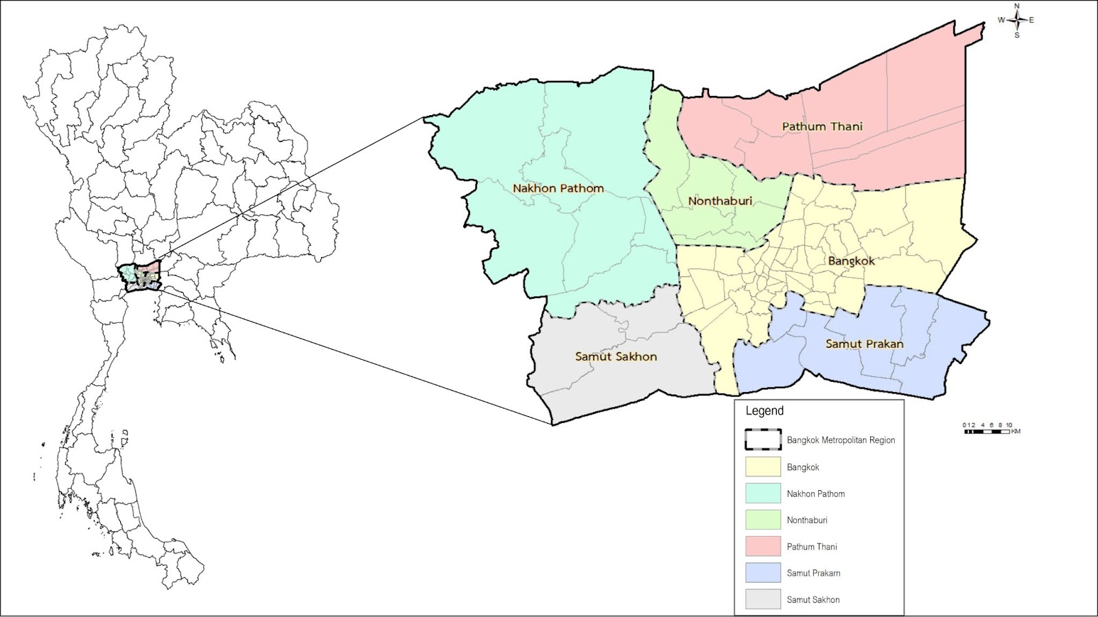
Figure 1. A map of the Bangkok Metropolitan Region.

2.2 Google Earth Engine
Google Earth Engine stands as a revolutionary cloud-based platform developed by Google, designed to facilitate highly scalable remote sensing data analysis. This cutting-edge platform offers users seamless access to an extensive array of satellite imagery datasets and remote sensing data, sourced from a diverse range of providers, including Landsat, Sentinel, MODIS, and more (Ermida et al., 2020). One of Google Earth Engine's key advantages is its capacity to empower academics, scientists, and policymakers by allowing them to carry out quick and extensive image analysis and processing. The platform gives users access to a number of tools and features for picture analysis, mapping, and visualization, making it easier to keep track of environmental, land use, and other changes. In this research we utilize this platform to retrieve LST, NDVI and NDBI (shown in figure 2). Furthermore, Google Earth Engine fosters collaboration and data sharing among users, facilitating collaborative research. In sum, Google Earth Engine stands as a potent instrument for remote sensing data analysis and area development monitoring, empowering users to extract invaluable insights into the shifts occurring in both natural and urban settings. These insights, in turn, bolster the pursuit of sustainable management and decision-making (Ermida et al., 2020).

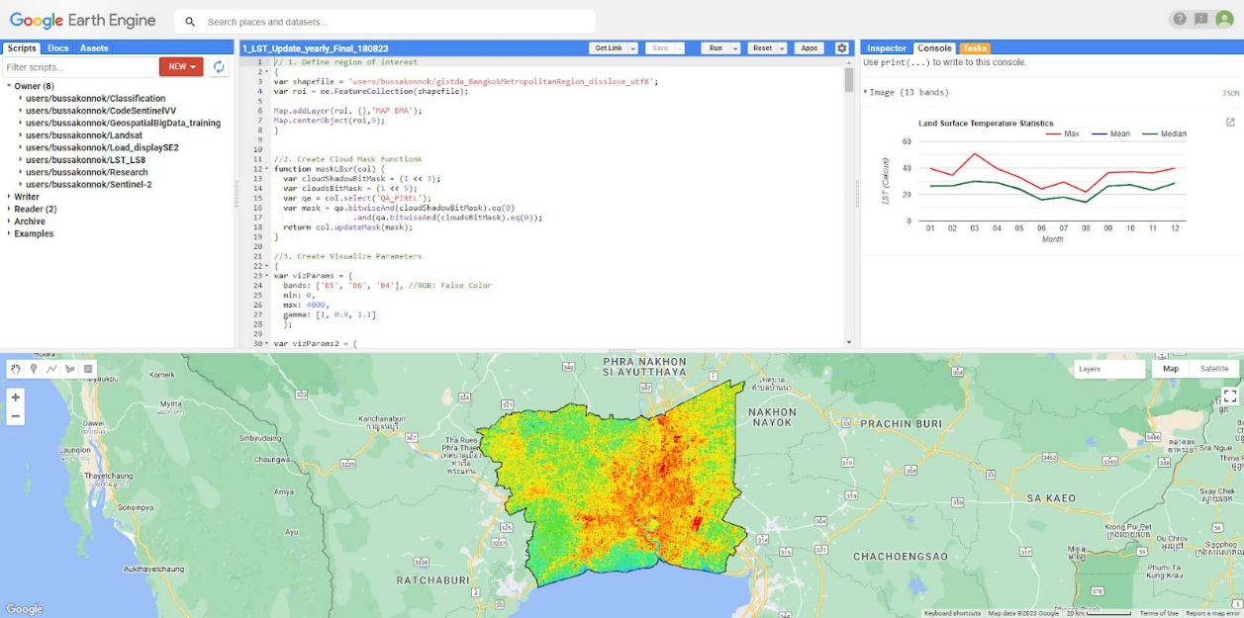
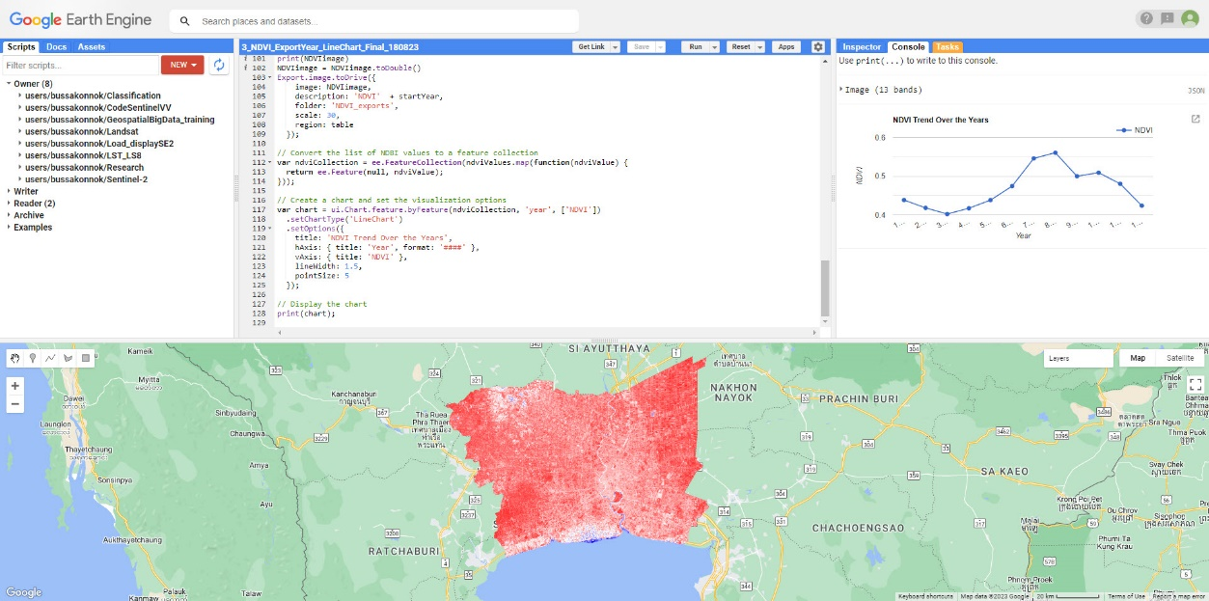
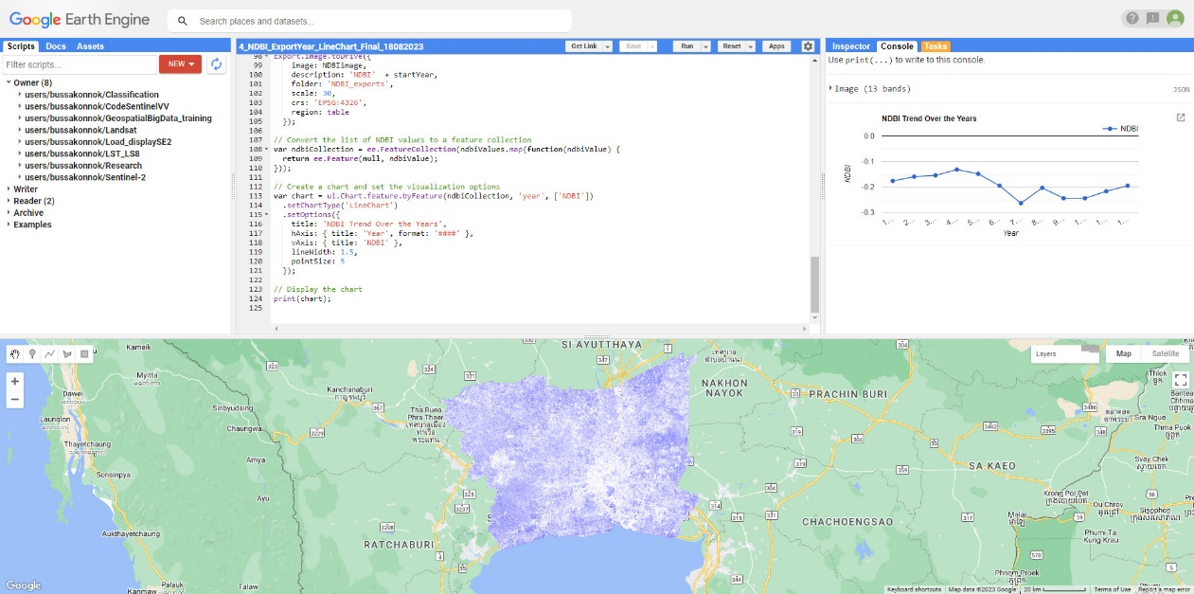
Figure 2. LST, NDVI and NDBI were retrieved from Google Earth Engine.

2.3 Data Retrieval
Landsat-8, officially known as the Landsat Data Continuity Mission (LDCM), is an Earth observation satellite launched by NASA (National Aeronautics and Space Administration) in partnership with the United States Geological Survey (USGS). It was launched on February 11, 2013. The Landsat 8 satellite payload consists with two primary sensors-the Operational Land Imager (OLI) sensor and the Thermal Infrared Sensor (TIRS). These two sensors provide seasonal coverage of the global landmass at a spatial resolution of 30 meters (visible, NIR, SWIR); 100 meters (thermal); and 15 meters (panchromatic). Landsat 8 was developed as a collaboration between NASA and the U.S. Geological Survey (USGS). It plays a crucial role in the estimation of land surface temperature, providing valuable data for various Earth science and environmental applications (https://www.usgs.gov/landsat-missions/landsat-8).
In this research for collecting Land Surface Temperature (LST), Normalized Difference Vegetation Index (NDVI) and Normalized Difference Built-Up Index (NDBI) was acquired from Landsat-8 satellite by using imagery from Path 150 and Row 50-51. The dataset was obtained from reputable sources such as the USGS Earth Explorer (Table 1).

Table 1. Landsat 8 band designations for the Operational Land Imager (OLI) and Thermal Infrared Sensor (TIRS)
Landsat 8  Operational  Land Imagery  (OLI)  and  Thermal  Infrared  Sensor  (TIRS)  Launched  February 11, 2013 | Bands | Wavelength  (micrometers) | Resolution  (meters)
 | Band 1 - Coastal Aerosol | 0.43 - 0.45 µm | 30
 | Band 2 - Blue | 0.450 - 0.51 µm | 30
 | Band 3 - Green | 0.53 - 0.59 µm | 30
 | Band 4 - Red | 0.64 - 0.67 µm | 30
 | Band 5 - Near-Infrared | 0.85 - 0.88 µm | 30
 | Band 6 - SWIR 1 | 1.57 - 1.65 µm | 30
 | Band 7 - SWIR 2 | 2.11 - 2.29 µm | 30
 | Band 8 - Panchromatic | 0.50 - 0.68 µm | 15
 | Band 9 - Cirrus | 1.36 - 1.38 µm | 30
 | Band 10 - TIRS 1 | 10.6 - 11.19 µm | 100
 | Band 11 -TIRS 2 | 11.5 - 12.51 µm | 100

2.4 Methods
This research utilizes remote sensing data to derive Land Surface Temperature (LST) values, employing the Mono-Window Algorithm, utilizing imagery from the Landsat 8 satellite equipped with a thermal infrared sensor known as the Thermal Infrared Sensor (TIRS) used the mono-window algorithm (MWA). The method of determination is as follows (Rongali et al.,2018). Additionally, the retrieval of the Normalized Difference Vegetation Index (NDVI) involves the utilization of data from the Near-Infrared (NIR) band and the Red band. Furthermore, the determination of the Normalized Difference Built-up Index (NDBI) is accomplished through the analysis of specific spectral bands, specifically, the Near-Infrared (NIR) Band and the Shortwave Infrared (SWIR) Band. In this research, we leverage the power of Google Earth Engine (GEE), employing a comprehensive workflow encompassing several intermediate steps to ensure precision and reliability. This study analyzes the trends of LST map over two periods in 2014 and 2021. Based on classification and estimation of satellite images over the study area, LST, NDVI, and NDBI. The Pearson correlation coefficient, also referred to as a bivariate correlation, serves as a statistical metric commonly employed to evaluate the association between Land Surface Temperature (LST) and both the Normalized Difference Vegetation Index (NDVI) and the Normalized Difference Built-up Index (NDBI). This metric is widely utilized for quantifying correlations between pairs of variables. The analytical framework for this assessment is depicted in Figure 3.
2.4.1 Retrieval of Land Surface Temperature
2.4.1.1 Calculation of TOA (Top of Atmospheric) spectral radiance
TOA (L) = ML * Qcal + AL
Whereas ML = Band-specific multiplicative rescaling factor from the metadata (RADIANCE_MULT_BAND_x, where x is the band number). Qcal = corresponds to band 10 and AL = Band-specific additive rescaling factor from the metadata (RADIANCE_ADD_BAND_x, where x is the band number).
2.4.1.2 TOA to Brightness Temperature conversion
BT = (K2 / (ln (K1 / L) + 1)) − 273.15
Whereas K1 = 1321.08 is a Band-specific thermal conversion constant from the metadata and K2 = 774.89 is a Band-specific thermal conversion constant from the metadata.
Therefore, to obtain the results in Celsius, the radiant temperature is adjusted by adding the absolute zero (approx. -273.15°C).
2.4.1.3 Calculate the NDVI
The NDVI was used to employ the amount of healthy green cover. Its Normalized Difference Formula along with the chlorophyll region of strong reflection and absorption. It is made effective for a wide range of terms by comparing the spectral properties of red and NIR waves.
NDVI = (NIR - R) / (NIR + R)
Whereas Red is (Band 4) with a wavelength of (0.64-0.67 m) and NIR is (Band 5) with a wavelength of (0.85-0.88 m). The range of the NDVI index is from -1 to 1. It typically falls between 0.2 to 0.8 for green plants.
2.4.1.4 Calculate the proportion of vegetation (Pv)
Pv = Square ((NDVI – NDVImin) / (NDVImax – NDVImin))
Whereas NDVI was calculated using Landsat-8's surface reflectance
2.4.3.1.5 Calculate Emissivity (ε)
ε = 0.004 * Pv + 0.986
Whereas 0.986 is for correcting the value of the equation. Simply apply the formula in the raster calculator, the value of 0.986 corresponds to a correction value of the equation.
2.4.1.6 Calculate the Land Surface Temperature
LST = (BT / (1 + (0.00115 * BT / 1.4388) * Ln(ε)))
Whereas 𝜆 = 0.000010895 is the wavelength of emitted radiance and 𝜌= 0.01439 is the constant value.
2.4. 2 Retrieval of Normalized Difference Vegetation Index (NDVI)
NDVI = (NIR - R) / (NIR + R)
Whereas NIR = Near-infrared Band and R = Red Band, as given in Eq 2.4.1.3.
2.4. 3 Retrieval of Normalized Difference Built-Up Index (NDBI)
NDBI = (NIR - SWIR) / (NIR + SWIR)
Whereas SWIR is Band 6 wavelength of (1.566- 1.652). The range of the NDBI value is from -1 to +1. Higher NDBI values indicate built-up regions, whereas lower values indicate water bodies. The vegetation NDBI value is low.

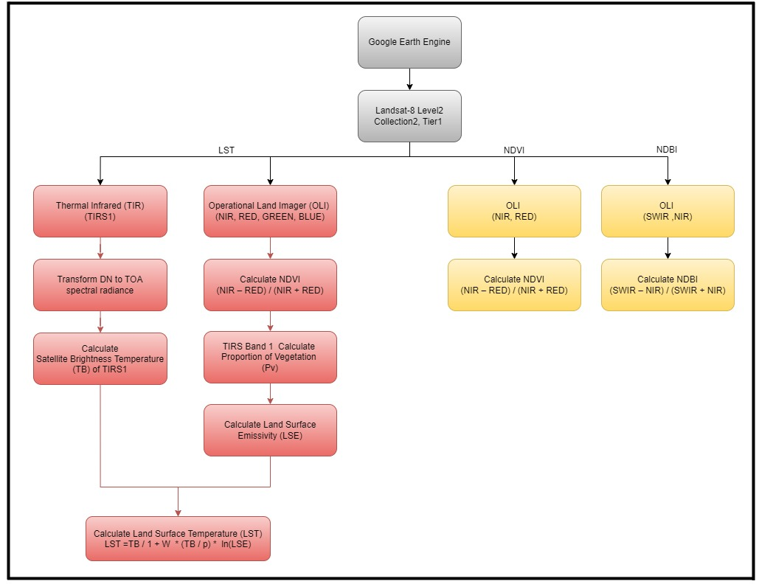
Figure 3. Analysis framework.

3. RESULTS AND DISCUSSION
3.1 Land Surface Temperature
For LST examination retrieval from the LANDSAT-8 satellite, Band 10 (wavelength range 10.60 - 11.19 nanometers), which corresponds to the Thermal Infrared spectrum (TIRS), with a spatial resolution of 100 meters, we conducted an analysis and data processing of thermal infrared radiation used the mono-window algorithm (MWA). The summer season in Thailand, which lasts from February to May every year, was specifically studied during this research period. The goal of this study was to identify clearer conditions and less cloud cover in Landsat data. This analysis was used to derive Land Surface Temperature (LST) in degrees Celsius. The goal was to examine the differences in land surface temperature within the Bangkok Metropolitan Region area. The LST maps were classified and estimated based on satellite images during the period of time 2014 and 2021 (shown in Figure 4).

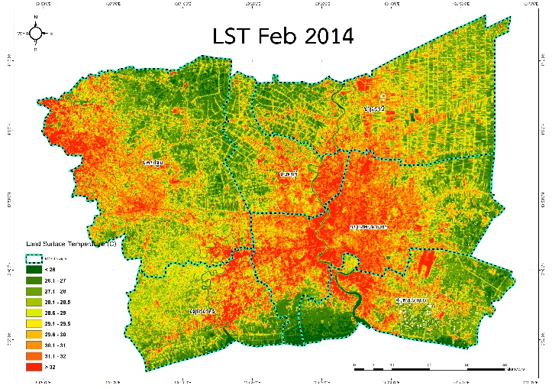 | 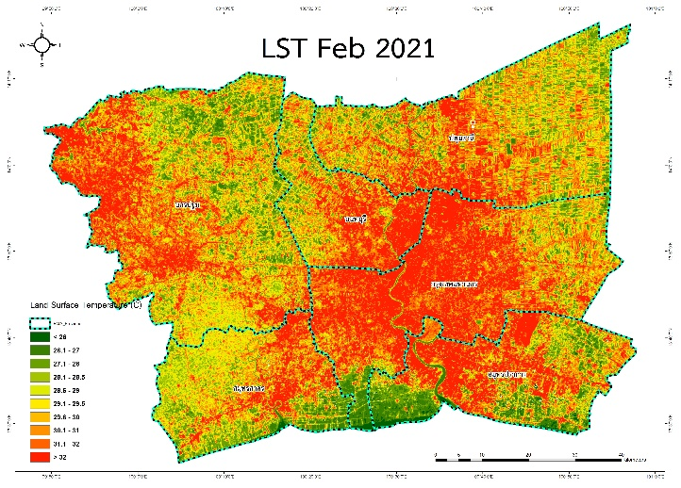
Figure 4. Comparison between LST map of February, 2014 and 2021 using Mono-window algorithm in GEE.

In 2014, the area with Land Surface Temperature (LST) in the range of 32 degrees Celsius covered 394.17 square kilometers, while in 2021, the same temperature range covered 1,155.24 square kilometers. The land surface temperature values below 29 degrees Celsius in the year 2014 have larger areas compared to the year 2021, and the surface temperature values above 29 degrees Celsius in the year 2021 have larger areas compared to the year 2014. This indicates that from 2014 to 2021, areas with surface temperatures above 29 degrees Celsius have increased over the study area (as shown in Figure 5).

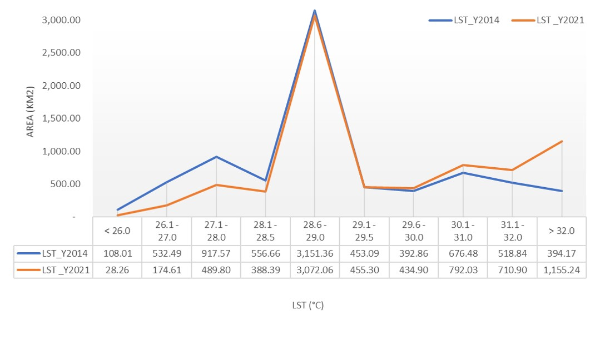
Figure 5. Comparison between Area and LST values from Landsat 8 of February, 2014 and 2021

3.2 Normalized Difference Vegetation Index (NDVI)
The Normalized Difference Vegetation Index (NDVI) is an index used to measure the health and growth of vegetation in a specific area. The calculation of NDVI is based on the Landsat 8 imagery equipped with an Operational Land Imager (OLI), which employs Red band and Near Infrared or NIR band. The NDVI calculation is carried out using the formula specified in section 2.4.3. The NDVI maps were classified into two distinct categories: vegetation and non-vegetation. Furthermore, the NDVI measurements were also used to examine how the NDVI related to LST between the years 2014 and 2021 (as shown in Figure 6).

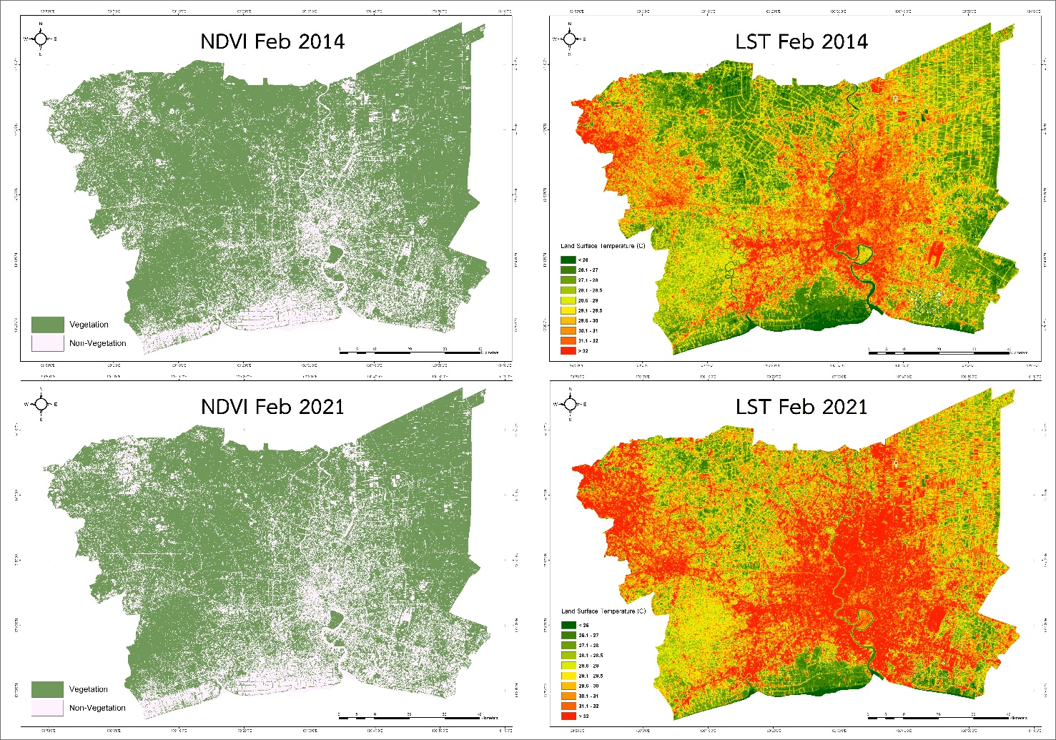
Figure 6. Comparison map between NDVI and LST in February, 2014 and 2021

Based on the information from the NDVI plots, the following observations can be made. From 2014, NDVI values ranged from -0.15 to 0.86, while LST values ranged from 24.70 to 35.61 degrees Celsius. From 2021, NDVI values ranged from -0.33 to 0.84, while LST values ranged from 25.16 to 38.64 degrees Celsius. In both 2014 and 2021, there is an inverse relationship between NDVI and LST. When NDVI is high, LST tends to be low, and when NDVI is low, LST tends to be high (as shown in Figure 7).
In both 2014 and 2021, there is a trend of decreasing NDVI values and increasing LST values (shown by the orange lines in the figure 7). This indicates that as NDVI decreases, LST tends to increase. These observations suggest that there is a negative correlation between NDVI and LST.

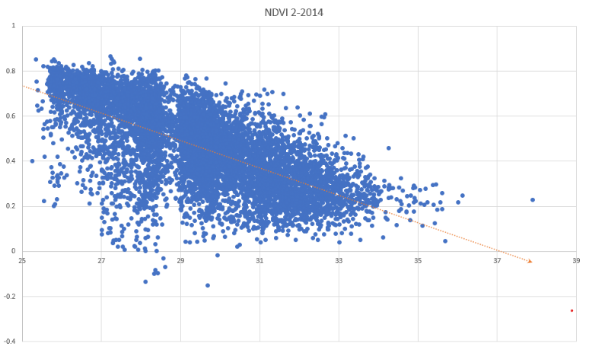 | 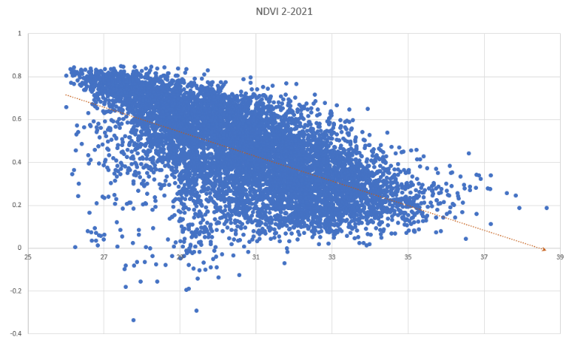
Figure 7. Graph showing the relationship between LST and NDVI in February, 2014 and 2021.

3.3 Normalized Difference Built-Up Index (NDBI)
Normalized Difference Built-Up Index (NDBI) is an index used to detect and quantify built-up or urban areas within a specific region. The calculation of NDBI is based on the Landsat 8 equipped with an Operational Land Imager (OLI), which utilizes Near-Infrared (NIR) Band and Shortwave Infrared (SWIR) Band. The NDBI calculation is performed using formula specified in section 2.4.3. NDBI is designed to highlight urban development and impervious surfaces. The NDBI maps were classified into two categories: Urban and non-urban. The NDBI measurements were also employed to examine the relationship between NDBI and LST from 2014 to 2021 (as shown in Figure 8).

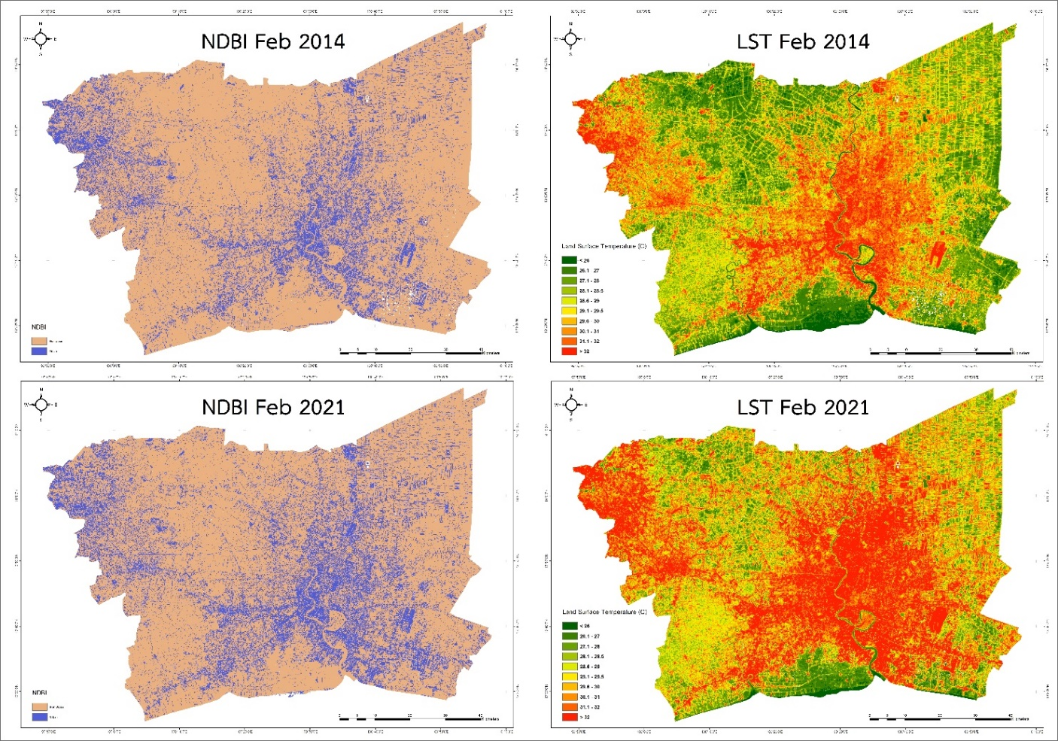
Figure 8. Comparison map between NDBI and LST in February, 2014 and 2021

Furthermore, the researchers have examined the relationship between the Normalized Difference Built-up Index (NDBI) and Land Surface Temperature (LST) for the years 2014 and 2021, revealing the following observations: In 2014, NDBI values spanned from -0.59 to 0.25, with corresponding LST values ranging between 24.70 and 35.61 degrees Celsius. In 2021, NDBI values ranged from -0.58 to 0.36, while LST values ranged from 25.16 to 38.64 degrees Celsius. In both 2014 and 2021, when NDBI values were low, LST values were also low, and conversely, when NDBI values were high, LST values exhibited higher values as well. Across the years 2014 and 2021, there is a consistent upward trend in both NDBI and LST values, as depicted by the orange lines in the figure. This trend underscores the positive correlation between NDBI and LST, indicating that as NDBI values increase, surface temperatures tend to rise (as shown in Figure 9).

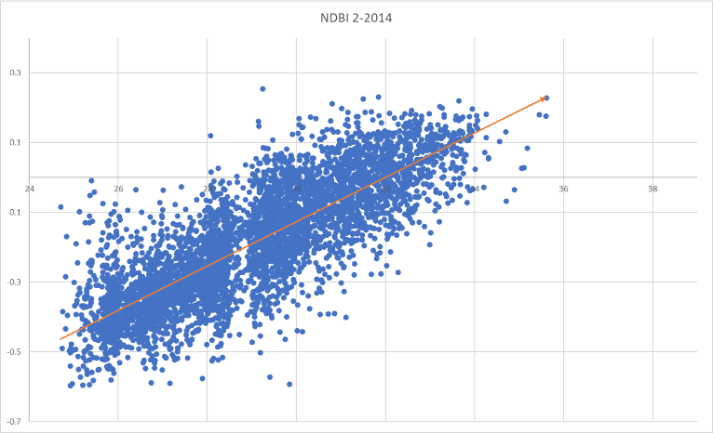 | 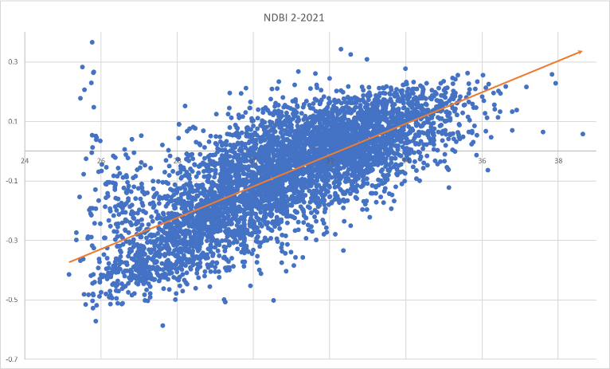
Figure 9. Relationship between LST and NDBI in February, 2014 and 2021.

3.4 Relationship between LST and NDVI
The analysis of the relationship between Land Surface Temperature (LST) and the Normalized Difference Vegetation Index (NDVI) involved the extraction of pixel values from LST and NDVI data for each individual pixel. Subsequently, we paired these values and utilized polynomial statistical methods and R-Squared values for the years 2014 and 2021 to establish relationships among the variables. As depicted in Figure 10, In which the blue plus sign represents the data for the year 2014, and the orange color represents the data for the year 2021. The analysis revealed an inverse correlation. Higher values of the vegetation index were associated with lower surface temperatures, indicating that temperatures tend to decrease in areas with more greenery. In 2014, the correlation was 71% (r2 = 0.71), while in 2021, it increased to 85% (r2 = 0.85). These findings were further illustrated through scatter plots, also presented in Figure 10.
This analytical process is consistent with mathematical theory and enhances our understanding of the interrelationships within the data. The results of accuracy tests for both temperature measurements and vegetation index values, demonstrated their correctness and suitability for use in the analysis.

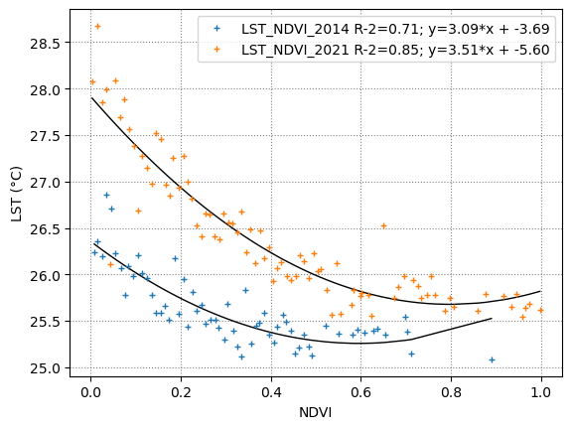
Figure 10. The R-Squared method's statistical comparison of LST and NDVI in the year 2014 and 2021

3.5 Relationship between LST and NDBI
The relationship between the Land Surface Temperature (LST) and the Normalized Difference Built-Up Index (NDBI) was investigated using pixel values for each individual pixel. In order to identify correlations between the variables, we paired these values, used polynomial statistical techniques, and calculated R-Squared values for the years 2014 and 2021. Based on the graphs obtained over the time period, which the blue plus sign represents the data for the year 2014, and the orange color represents the data for the year 2021. when the NDBI values are high, land surface temperatures also exhibit higher values. In 2014, the correlation was 79% (r2 = 0.79), while in 2021, it reached 90% (r2 = 0.90). This indicates that there is still a statistically significant positive association between these two parameters (as shown in Figure 11).
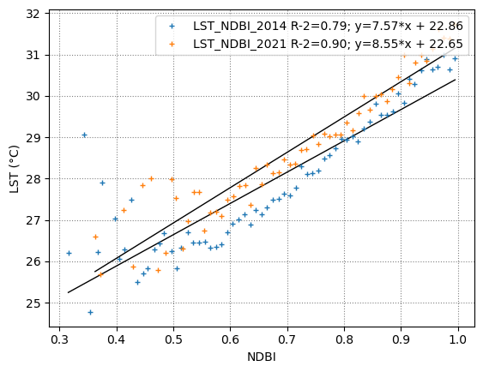
Figure 11. The R-Squared method's statistical comparison of LST and NDBI in the year 2014 and 2021

4. CONCLUSION
In this study, the researchers analyzed the trends of Land Surface Temperature using Normalized Difference Vegetation Index (NDVI) and Normalized Difference Built-Up Index (NDBI) derived from Landsat 8 imagery through the Google Earth Engine platform. The investigation focused on the Bangkok metropolitan area and its suburbs to examine changes during the years 2014 and 2021. For this analysis, the researchers employed the Mono-window algorithm to estimate LST and explored the relationships between LST, NDVI, and NDBI during selected time periods. The analysis of LST reveals that the Bangkok metropolitan and suburban areas encompass a total area of 7,701 square kilometers, where the LST values exceeded 29 degrees Celsius. In the year 2014, this area measured approximately 2,435.45 square kilometers, equivalent to approximately 31.62% of the total area. In contrast, in 2021, the area increased to approximately 3,548.37 square kilometers, representing around 46.07% of the total area. It is noteworthy that the areas with significantly high LST values witnessed substantial growth within the study period in both years under examination. In the comparative analysis between LST and NDVI. It was observed that when NDVI values are low, LST tends to be high, whereas when NDVI values are high, LST tends to be low. This illustrates an inverse relationship, which is evident from the relationship graph in Figure 7. This suggests that areas with dense vegetation tend to have lower surface temperatures. The comparative analysis between LST and NDBI revealed a direct proportional relationship. It was observed that as LST increases, the NDBI values also increase. This relationship is clearly depicted in Figure 9. This implies that urban development has an impact on surface temperature and contributes to temperature variability in the area. Therefore, this study concludes that areas with a high vegetation cover can effectively contribute to reducing surface temperatures. Additionally, the Built-up Index (NDBI) exhibits a corresponding change in surface temperature. The relationship between NDVI and NDBI is crucial as an indicator of the Urban Heat Island phenomenon in urban areas, aiding in our understanding of the environmental impacts of urban development. This research serves to enhance our existing knowledge about urban environmental assessment and sustainable urban development.

5. REFERENCES
Ermida, S. L., Soares, P., Mantas, V., Göttsche, F.-M., & Trigo, I. F. (2020). Google Earth Engine Open-Source Code for Land Surface Temperature Estimation from the Landsat Series. Remote Sensing, 12(9), 1471. DOI: 10.3390/rs1209147
Rongali, G., Keshari, A.K., & Gosain, A.K. (2018). A Mono-Window Algorithm for Land Surface Temperature Estimation from Landsat 8 Thermal Infrared Sensor Data: A Case Study of the Beas River Basin, India. ResearchGate, 2018.
Khamchiangta, D., & Dhakal, S. (2020). Time series analysis of land use and land cover changes related to urban heat island intensity: Case of Bangkok Metropolitan Area in Thailand. ResearchGate, DOI: 10.1016/j.jum.2020.09.001.
Oke, T. R. (1982). The energetic basis of the urban heat island. Quarterly Journal of the Royal Meteorological Society, 108(455), 1-24, DOI:10.1002/qj.49710845502.
Sopha, P. (2019). A Relationship Between Land Surface Temperature from Landsat 8 TIRS Imagery and Normalized Difference Vegetation Index, Enhanced Vegetation Index, and Normalized Difference Built Index in Bangkok and Metropolitan Region. Bangkok: Chulalongkorn University.
USGS. (2016b). LANDSAT image data. U.S. Department of the Interior. U.S. Geological Survey. Retrieved from https://earthexplorer.usgs.gov/.

